

LAB REPORT
CSE312: Database Management System Lab

Submitted To
Syed Eftasum Alam (SEA)
(Lecturer)
Department of CSE, Daffodil International University

Submitted By
Student ID: 232-15-818
Section: 66_L2
Student Name: Md. Emon Hossain

Date of Lab Report Submission: 05 February 2026
Experiment No: 01 | Experiment Name: Design and Implementation of Hospital Database Using SQL DDL.
1. Experiment Details:
Create a database named Hospital and design the following tables:
- Doctor {d_id(pk), d_name, specialist, room_no(fk)}
- Patient {p_id (pk), p_name, diagnosed_with, room_no (fk), assigned_doctor(fk)
- Room {room_no(fk), type (ward, cabin, vip cabin, doctor_chamber)}
All key and required fields must be defined using the NOT NULL constraint.

2. Software & Tools Used:
- Web Server Stack: XAMPP Control Panel v3.3.0
- Database Management System: MariaDB 10.4.x (MySQL-compatible)
- Database Server: MySQL Server (running on localhost via XAMPP)
- Interface Tool: phpMyAdmin 5.2.x
- Web Server: Apache 2.4.x
- Scripting Language: PHP 8.0.x
- Operating System: Windows 11

3. Methodology:
- Created the Hospital database using the CREATE DATABASE command.
- Selected the database using the USE command.
- Created the Room table as the parent entity.
- Created the Doctor table with a foreign key reference to the Room table.
- Created the Patient table with foreign key references to both Room and Doctor tables.
- Applied NOT NULL constraints to all key and mandatory attributes.
- Verified table creation and structure using SQL queries.

4. Experiment Solutions:

Step-01: CREATE DATABASE (Hospital)

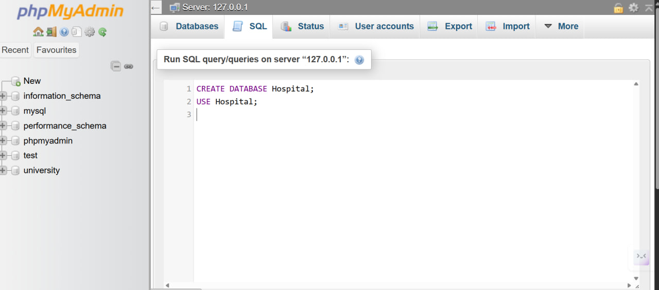

Step-02: Success of Compilation (Hospital)

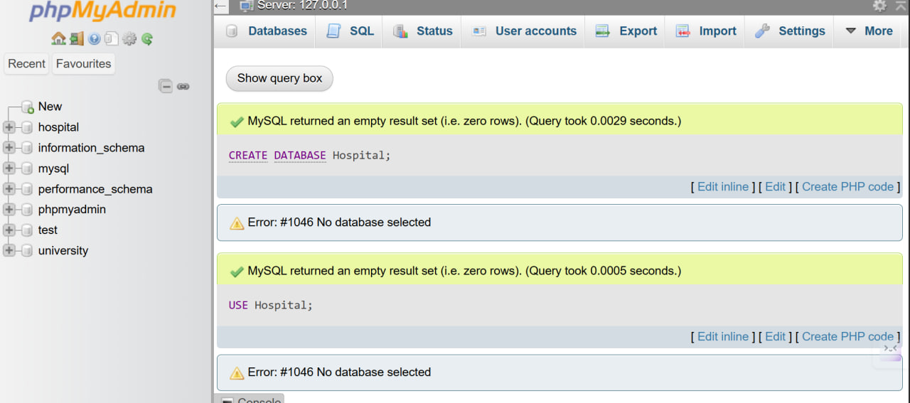

Step-03: SQL Queries (Create Room Table)

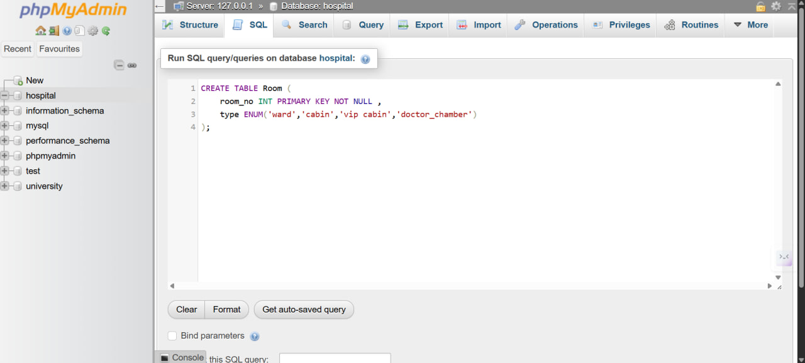

Step-04: Success of Compilation (Room Table)

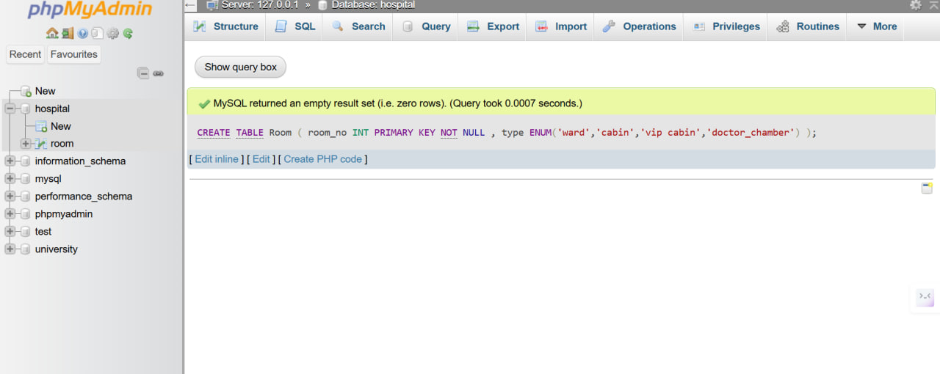

Step-05: Output (Room)

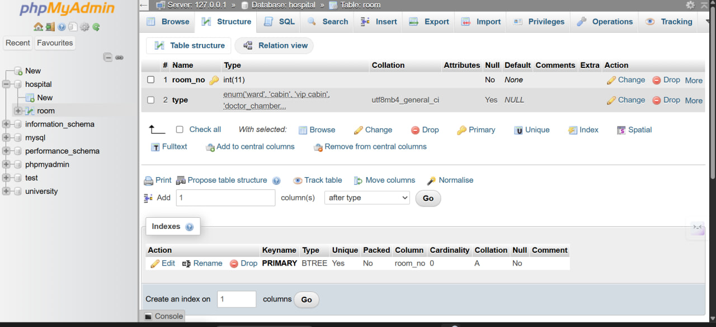

Step-06: SQL Queries (Create Doctor Table)

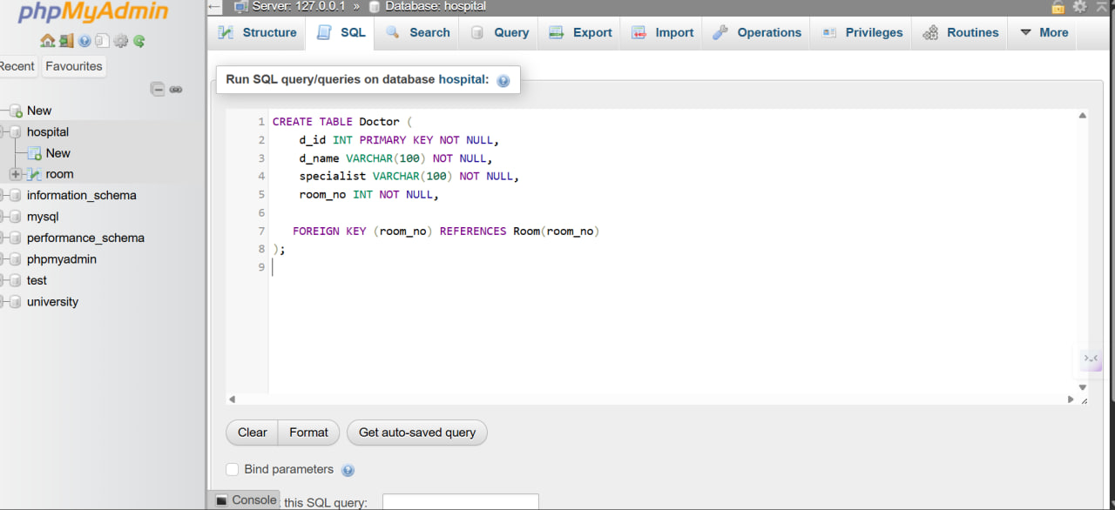

Step-07: Success of Compilation (Doctor Table)

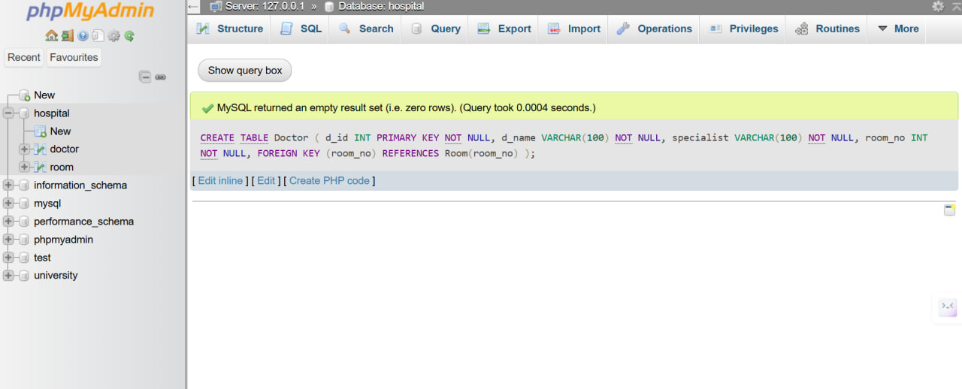

Step-08: Output (Doctor)

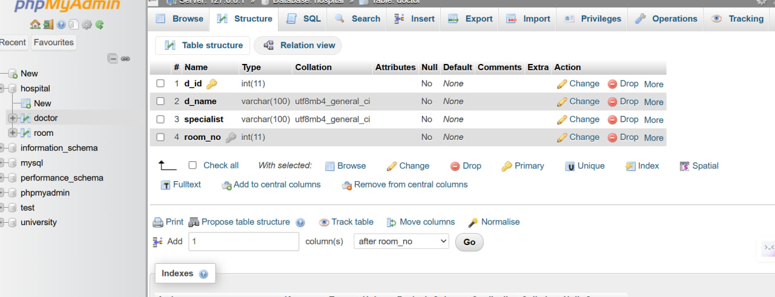

Step-09: SQL Queries (Create Patient Table)

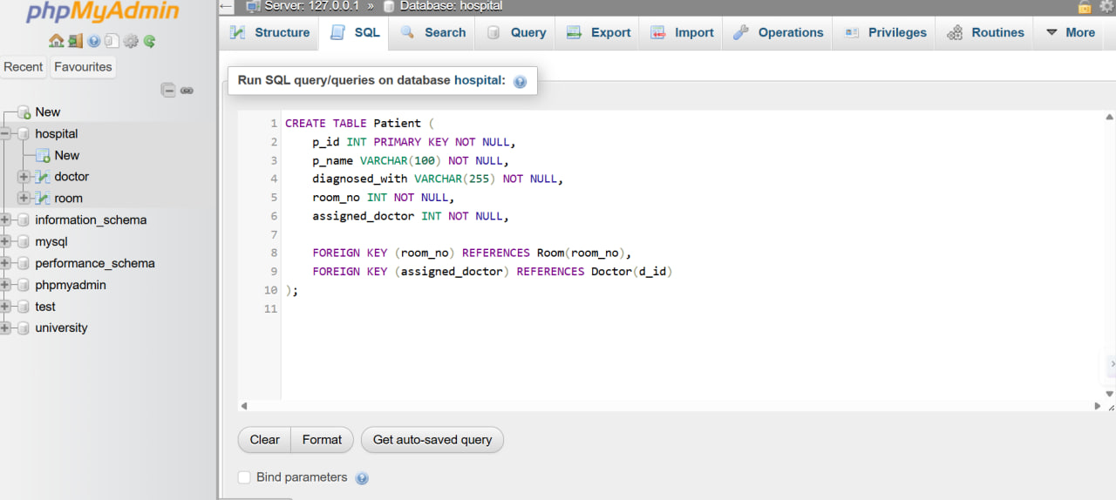

Step-10: Success of Compilation (Patient Table)

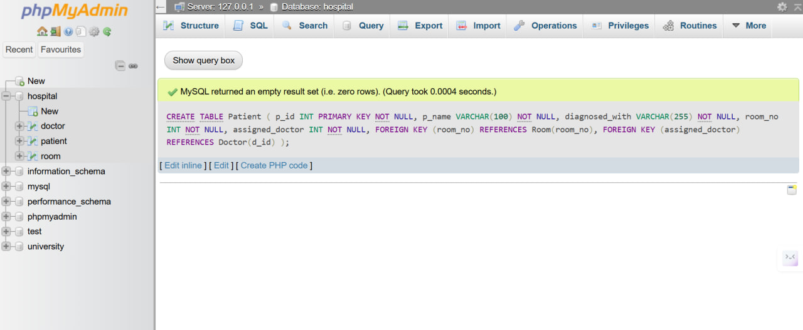

Step-11: Output (Patient)

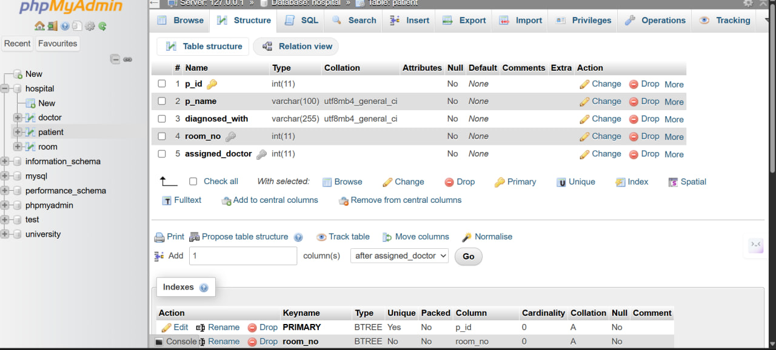

4.1. Alternative Steps:

Step-01: CREATE DATABASE (Hospital)



Step-02: Success of Compilation (Hospital)



Step-03: SQL Queries (Create Doctor Table)

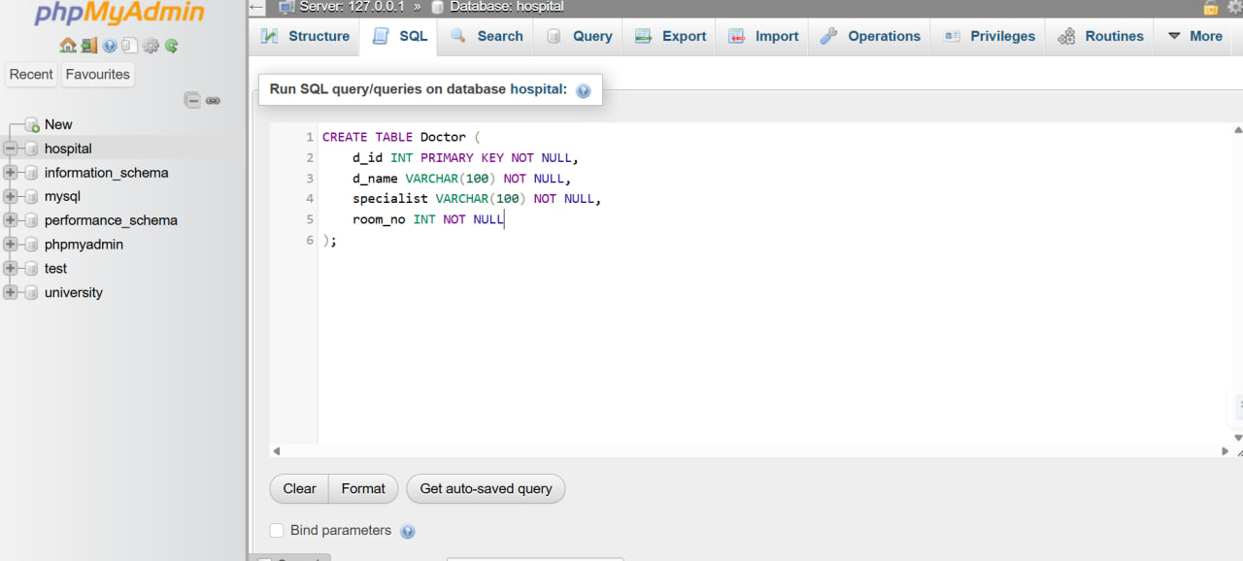

Step-04: Success of Compilation (Doctor Table)

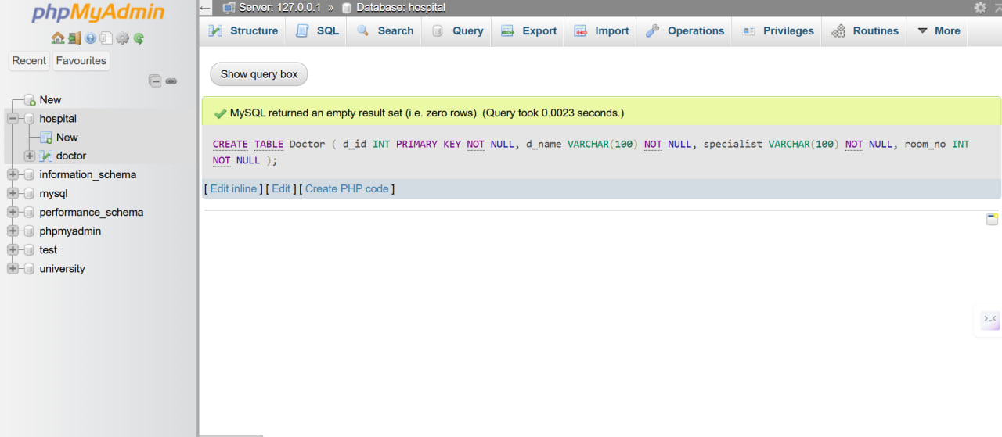

Step-05: Output (Doctor Table)

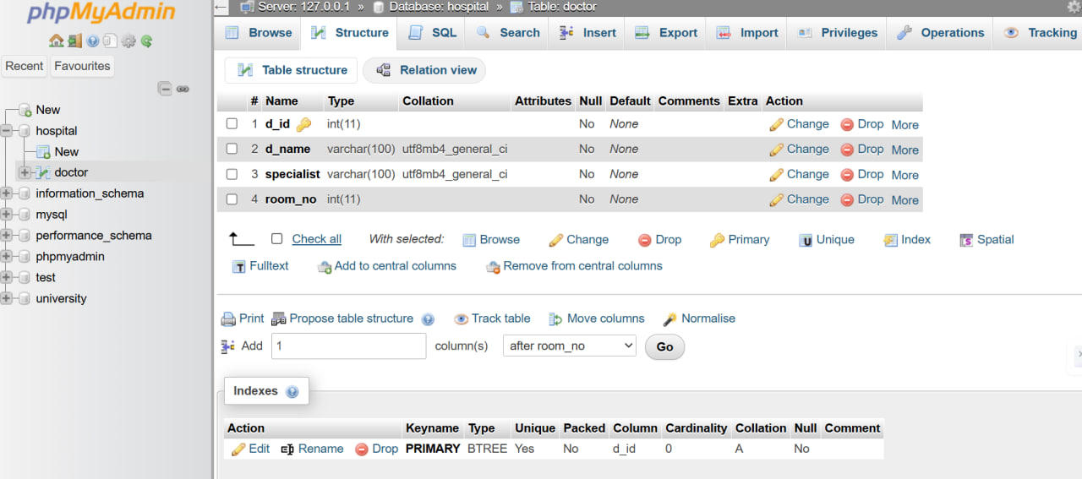

Step-06: SQL Queries (Create Patient Table)

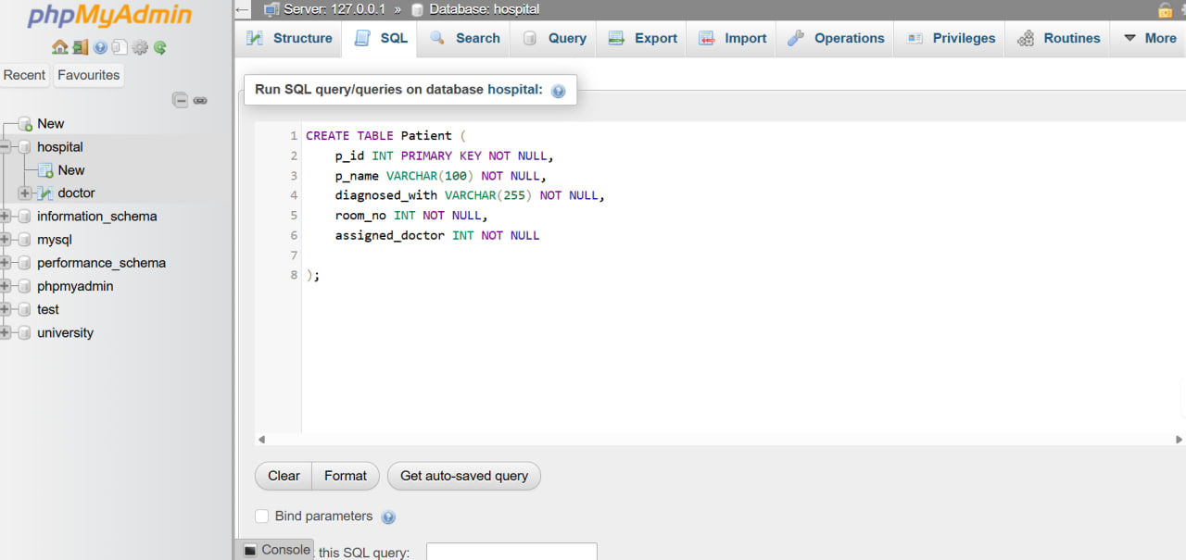

Step-07: Success of Compilation (Patient Table)

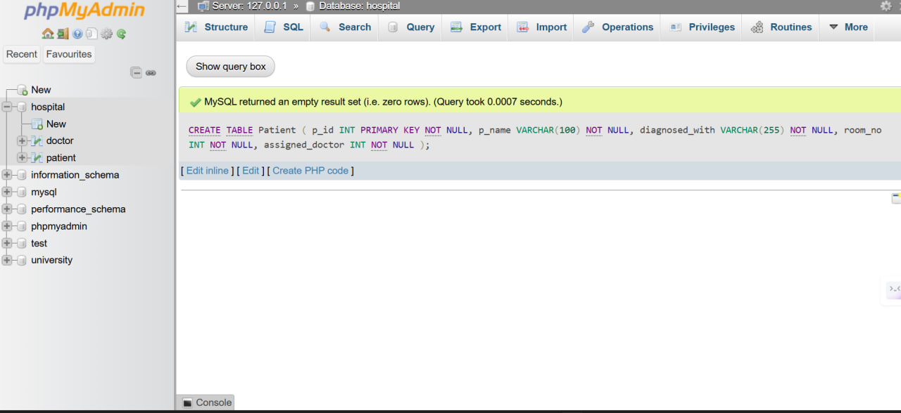

Step-08: Output (Patient Table)

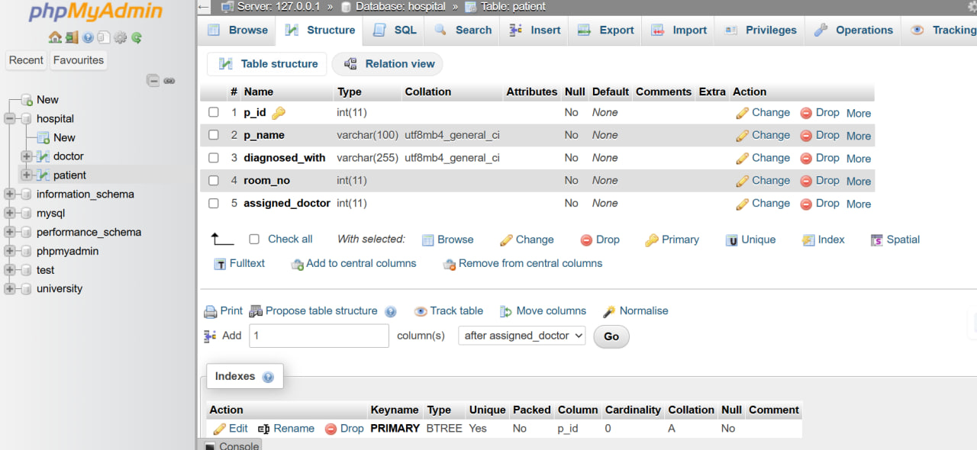

Step-09: SQL Queries (Create Room Table)

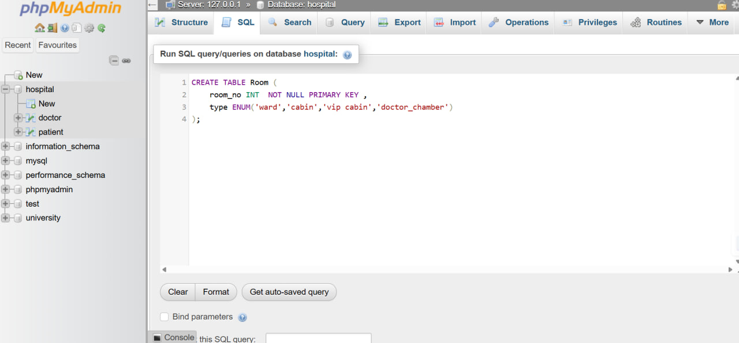

Step-10: Success of Compilation (Room Table)

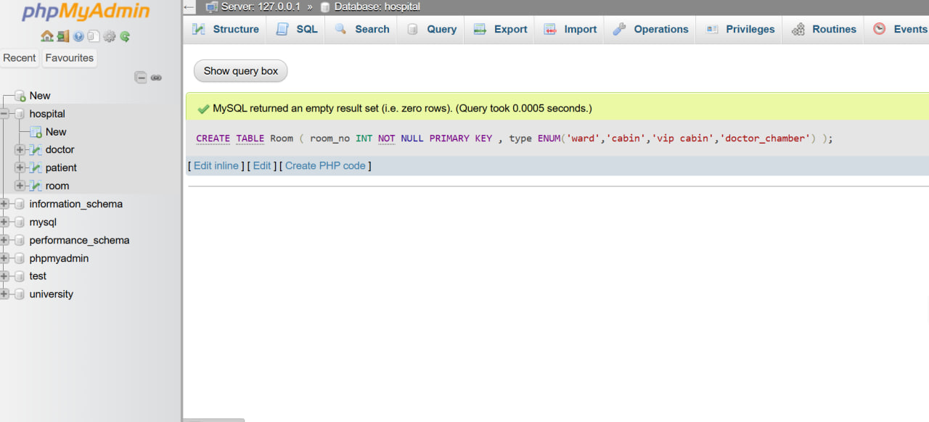

Step-11: Output (Room Table)

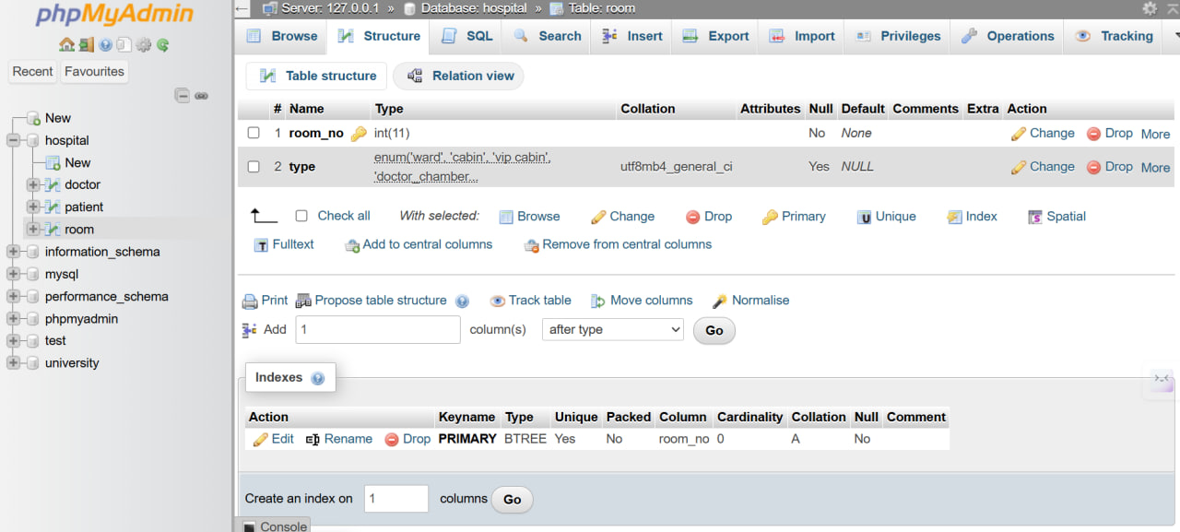

Step-12: SQL Queries (Add foreign key constraints after table creation)

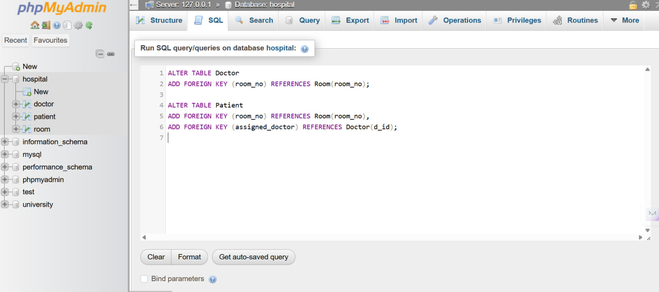

Step-13: Success of Compilation

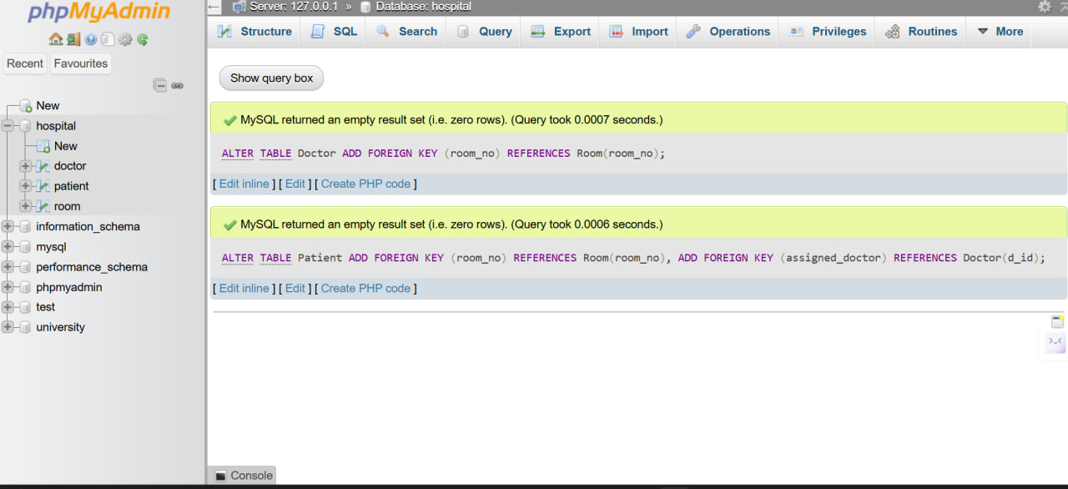

Step-14: Output

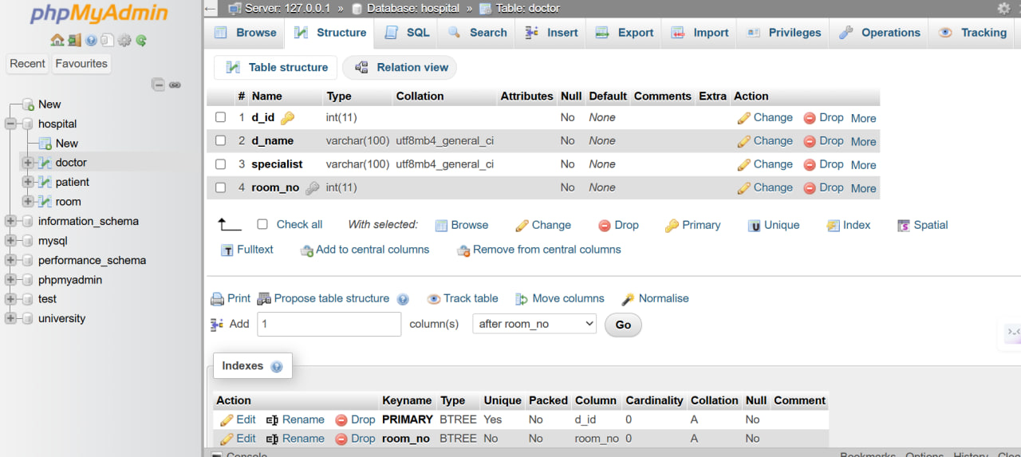

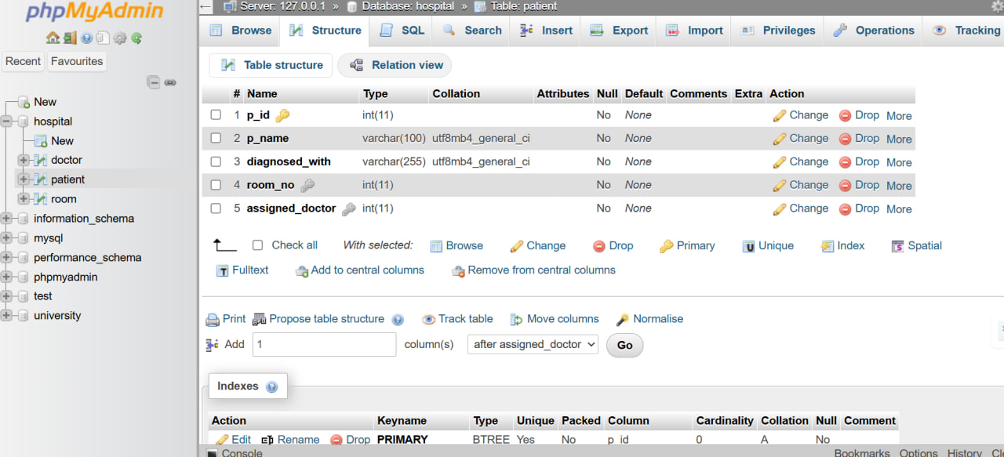

5. Observation:
- Primary and foreign key constraints were correctly applied.

- NOT NULL constraints ensured that all mandatory fields contain valid data.

- Referential integrity among the tables was successfully maintained.

- The experiment improved understanding of relational database schema design.

6. Appendix:

Appendix A: Course Outcomes, Complex Engineering Problems (EP) and Complex Engineering Activities (EA) Addressing.

Appendix A: Course Outcome (CO) Attainment

SN | COs | Attainment | Justification
01 | CO1 | Yes | These lab activities attain CO1 by practicing database creation and a couple of tables having at least 4-6 parameters and an interconnectedness between tables using primary key and foreign keys.
02 | CO2 | Yes | Implements relational integrity using keys and constraints.
03 | CO3 | No | Security and distributed DB topics are outside the scope.

Appendix B: Addressing Complex Engineering Problems (EP)

SN | Engineering Problem (EP) | Attainment | Related (CO) | Justification
01 | EP1: Depth of Knowledge | Yes | CO1, CO2 | Proper schema design and constraint usage.
02 | EP2: Conflicting Requirements | No | CO2 | Single-scope academic task.
03 | EP4: Familiarity of Issues | Yes | CO1 | Standard DBMS lab problem.
04 | EP7: Interdependence | Yes | CO2 | Inter-table dependency via foreign keys.

